Document No: Midterm Exam | REV No:/Date 2024/06/21
Course Title: | Power Electronics Applications and Designs (3E)
Course code: | EME409
Module Number:

DATE: 2024/06/21
INDEX NO: AA2176
TITLE: Boost converter.
OBJECTIVES: Familiarization with the operation of a simple Boost converter. Understanding the operation of an inductor, and switching operation of MOSFET. A boost converter steps up the input voltage to a higher output voltage.
Components: Capacitors (100uF x 2), Inductors (150mH), Diode (1N4003), 3.7v Battery cell, Signal generator, Multimeter.
Apparatus: Lab practical and proteus software/ LTspice software simulators.
Lab results:
Task 01: Draw a circuit diagram for the boost converter, and explain how it operates.
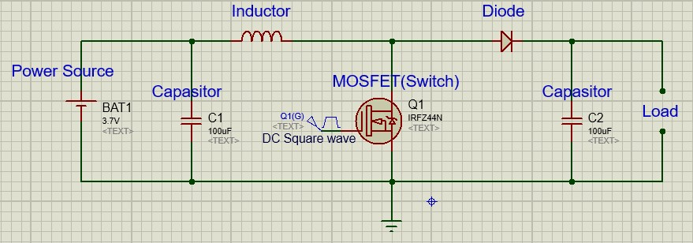
Result 01

An Inductor(L) - Stores energy when the MOSFET(Switch) is Closed.
Dide(D) - The diode allows current to flow only towards the output of the circuit. When the switch opens, it stops returning to the input side.
Output capacitor (C) - The output capacitor stabilizes the voltage across the load and smooths the output voltage.
- Mode 01 (MOSFET ON)
In this stage, the input voltage (V_{in}) is applied across the inductor (L) which increases the current through the inductor linearly. The inductor stores energy by generating a magnetic field, and the diode (D) is reverse-biased, preventing current flow to the load. The inductance current can be expressed as:
$$TOΔIL=\frac{VIN}{L}.N$$
- Mode 01 (MOSFET OFF)
Inductive current must continue to flow. This forces diode D to be forward-biased, and the inductor releases its stored energy into the load and output capacitor. During this period, the voltage across the inductor is equal to the difference between the output voltage (V_{out}) and the input voltage (V_{in}). The equation for the inductance current is:
$$ΔIL=\frac{VOUT-VIN}{L}.TOFF$$

Task 02: What is the meaning of the maximum power point tracking
Result 02
Maximum power point tracking (MPPT) is a technique used to maximize power output from variable power sources. It involves continuously adjusting the electrical operating point of the modules or arrays to ensure that the maximum possible power is delivered. A technique used to maximize the power source from power sources such as solar panels. The MPPT controller adjusts the voltage and current to ensure that the power source is operating at its maximum power point.

Task 03: What is the meaning of the power source
Result 03
A power source is any device or system that provides electrical energy or some other form of energy to a circuit or load.
Ex: - batteries, generators, solar panels, and power supplies.

Task 04: What are the conditions when the maximum power is being transferred (you need to derive an equation to show RS = RLoad)
Result 04
To transfer maximum power from a source to a load with an internal resistance, the load resistance must be equal to the source resistance. Therefore, the maximum power transfer occurs when the external resistance of the system is equal to the internal resistance. It can be expressed as follows:
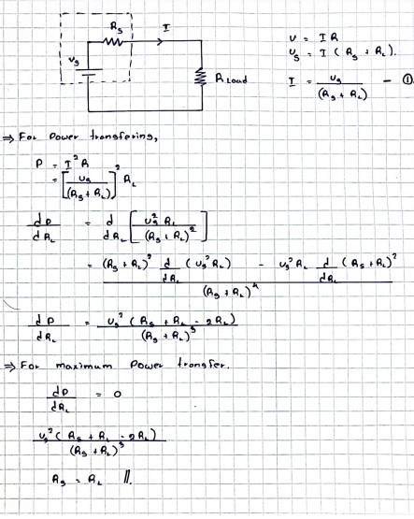

Task 05: Derive the equation for the voltage gain of the boost converter using the Duty cycle (D)
Result 05
Vin​: - Input voltage.
Vout: - Output voltage.
V_{L}: - Voltage across Inductor.
D: - Duty cycle.
T: - Total period.
f: - Switching frequency (f = 1/T)
ON state (0 < t < DT)
- The voltage across inductor V_{L}=V_{in}
- Duration DT
OFF state (DT < t < T)
- The voltage across inductor V_{L}=V_{in}−V_{out}
- Duration (1−D) T
Note: - The principle of inductor volt-second balance states that the average value, or dc component, of voltage applied across an ideal inductor winding must be zero.
Then,
Vin​.DT+(Vin​−Vout​). (1−D) T= 0
Vin​⋅D +Vin​⋅(1−D) − Vout​⋅(1−D) = 0
Vin​⋅D +Vin​ −Vin​⋅D −Vout​ +Vout​⋅D = 0
Vin ​= Vout​⋅(1−D)
Voltage Gain =$\frac{VOUT}{VIN}=\frac{1}{(1-D)}$ ……………………………………//

Task 06 Using LTspice, draw and simulate a simple boost converter
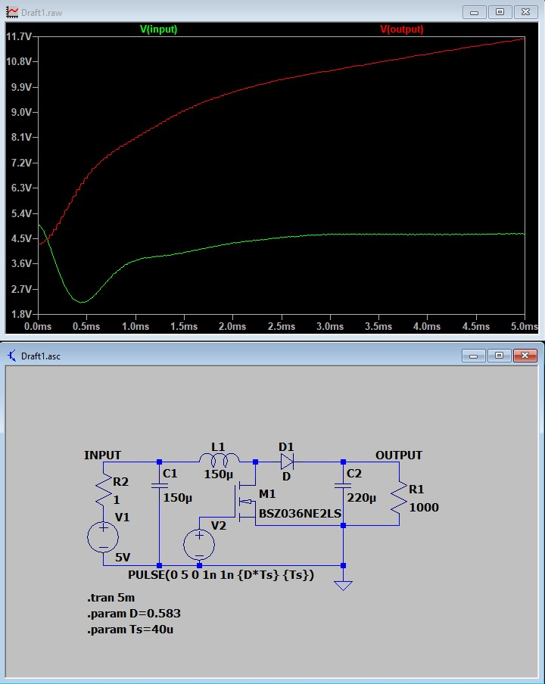
Result 06

